Heart Disease Prediction Using Machine Learning

Submitted By
Akanksha Choudhary
Roll No.: 240603010069
Department of Computer Science & Engineering
Government Degree College Dharamshala

Introduction

Heart disease is one of the leading causes of death worldwide. Early detection and diagnosis can significantly improve patient outcomes. Machine Learning enables computers to analyze large amounts of medical data and identify patterns that help predict heart disease. This project develops a prediction system using the Random Forest algorithm and provides an easy-to-use web application built with Flask.

Problem Statement
Traditional methods of diagnosing heart disease are often time-consuming and require multiple medical tests. There is a need for an intelligent system that can quickly predict the likelihood of heart disease using patient medical information.

Objectives
Existing System
- Diagnosis mainly depends on doctors' experience.
- Requires several laboratory tests.
- Time-consuming process.
- Higher medical costs.
- Possibility of human error.

Existing System
- Diagnosis mainly depends on doctors' experience.
- Requires several laboratory tests.
- Time-consuming process.
- Higher medical costs.
- Possibility of human error.

Proposed System
- Uses Machine Learning for prediction.
- Provides fast and accurate results.
- Reduces diagnosis time.
- User-friendly Flask web interface.
- Supports doctors in decision-making.

What is Machine Learning?
Machine Learning is a branch of Artificial Intelligence that enables computers to learn from data and make predictions without being explicitly programmed.
Types of Machine Learning
- Supervised Learning
- Unsupervised Learning
- Reinforcement Learning
This project uses Supervised Learning.

Random Forest Algorithm
Random Forest is an ensemble learning algorithm that builds multiple Decision Trees and combines their predictions using majority voting.
Advantages
- High accuracy
- Reduces overfitting
- Handles large datasets
- Works well with missing values
- Robust and reliable
Project Architecture
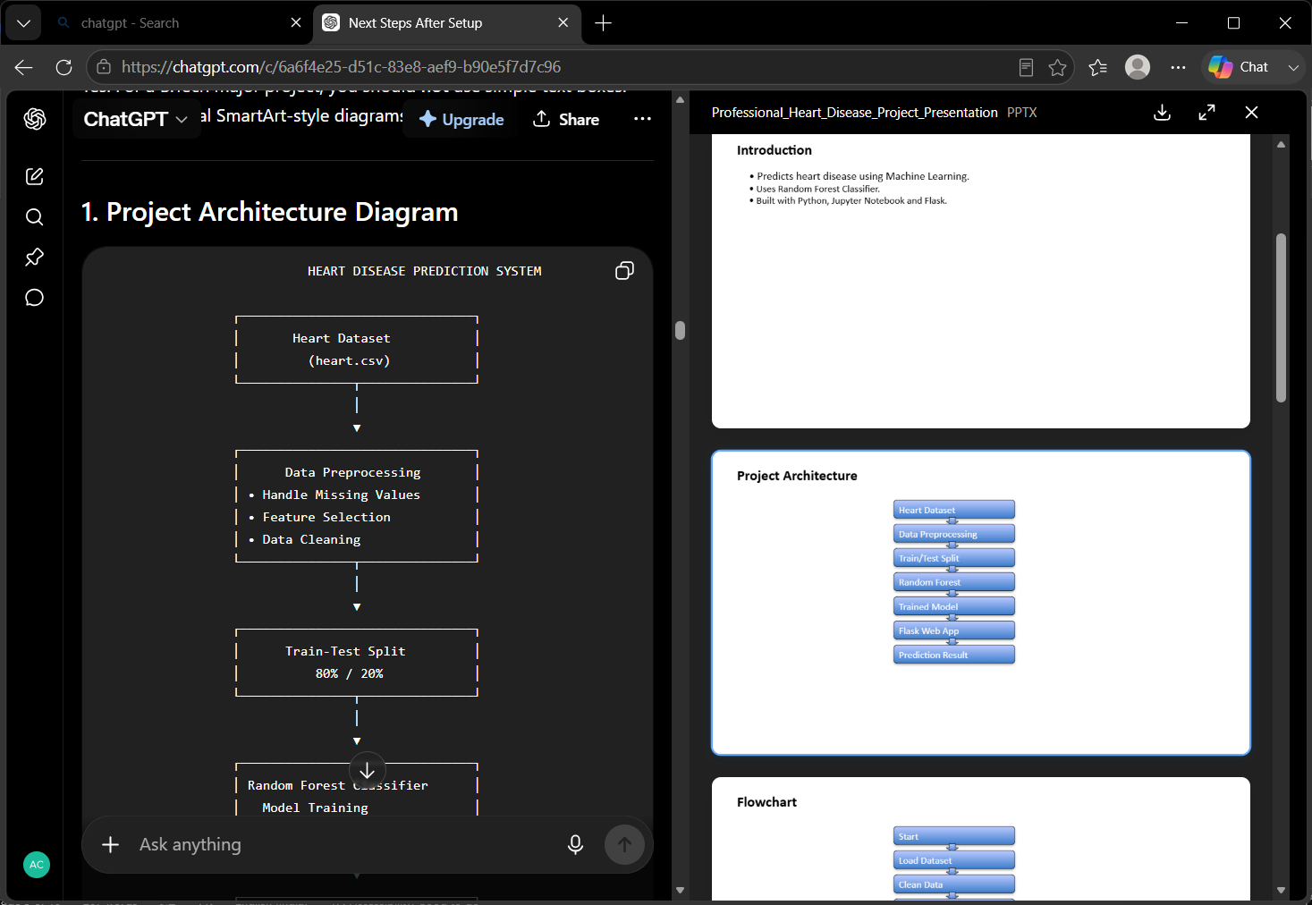
The dataset is cleaned and prepared before training the Random Forest model. The trained model is then integrated into a Flask web application, where users enter patient information and receive a prediction .
Flowchart
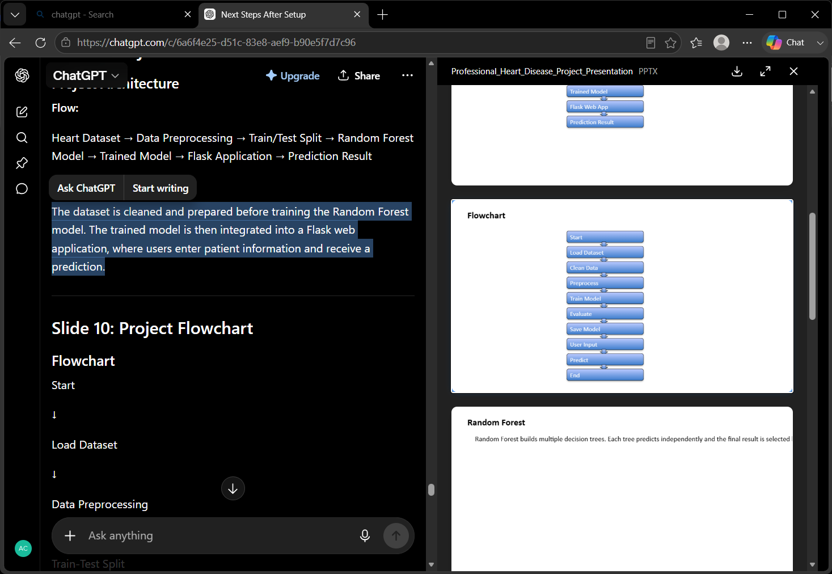

Dataset
The project uses the Heart Disease Dataset containing patient medical records.
Important Features
- Age
- Sex
- Chest Pain Type
- Resting Blood Pressure
- Cholesterol
- Fasting Blood Sugar
- Maximum Heart Rate
- Exercise-Induced Angina
- ST Depression
- Target Variable
Data Preprocessing
- Load dataset
- Check missing values
- Remove duplicate records
- Feature selection
- Split data into training and testing sets (80:20)

Model Training
The Random Forest algorithm learns patterns from the training dataset by creating multiple decision trees. Each tree contributes to the final prediction through majority voting.

Model Testing
The trained model is evaluated using the testing dataset to measure its prediction performance on unseen data.

Model Accuracy
Performance is measured using:
- Accuracy Score
- Precision
- Recall
- F1 Score
- Confusion Matrix
These metrics help evaluate how well the model predicts heart disease.

Confusion Matrix
The confusion matrix compares predicted results with actual results.
It consists of:
- True Positive (TP)
- True Negative (TN)
- False Positive (FP)
- False Negative (FN)
This helps identify the strengths and weaknesses of the model.

Flask Web Application
The Flask application provides a simple interface where users enter patient information. The trained model processes the data and displays whether the patient is likely to have heart disease.

Advantages
- High prediction accuracy
- Fast diagnosis
- Easy to use
- Cost-effective
- Supports medical professionals
- Reduces manual effort

Applications
- Hospitals
- Healthcare Centers
- Diagnostic Laboratories
- Telemedicine Systems
- Medical Research
- Health Monitoring Platforms

Future Scope
- Use larger medical datasets
- Deploy on cloud platforms
- Develop a mobile application
- Integrate IoT health devices
- Improve prediction using Deep Learning

Conclusion
This project successfully predicts heart disease using the Random Forest algorithm. It provides high prediction accuracy and a user-friendly web application. The system demonstrates how Machine Learning can support healthcare by assisting in early disease detection and improving decision-making.

